Quilting Patterns Light

NB: Due to the amount of patterns not all have been tested so are subject to change of Density. IE: Light to Medium
A Tisket A Tasket
Alternating Loops 1
All over loose Feather.png
Alternating Loops 2.png
Alternating Loops 3.png
Apples Leaves.png
Atta Boy.png
Bonny Flowers.png
Blossom Cluster.png
Blooms.png
Blossom.png
Butterflies And Loops.png
Broken Glass.png
Butterfly.png
Cheryls Gumnuts.png
Castel Scrolls.png
Clamshell with Curl.png
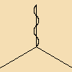
Chicken Wire.png
Chevron 4.png
Chevron 3.png
Clouds.png
Clamshell.png
Clamshell with Loop.png
Clover.png
Cornflower 2.png
Daisy Chain.png
Curls.png
Daisy Marie.png
Daisy.png
Daisy Scroll.png
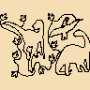
Dino Land.png
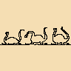
Dinosaurs.png
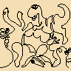
Dinomite.png
Double Swirls.png
EE Feather.png
Easy Geo.png
Dragonflies.png
Emily.png
Ethnic spiral Braid.png
Feather Flurry.png
Elegant Flowers.png
Feather Plump.png
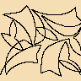
Feather in my hat.png
Feather Spine.png
Flight of swallows.png
Flutterbys.png
Flipped on Feathers.png
Greek.png
Fractial Element.png
Heart String.png
Indian Bows And Arrows.png
JsPanto Leaves.png
Jessica Tribal Switchback.png
JSBORD.png
Lasso.png
Lacey Swirls.png
LCPANTO Bubble Bath.png
LCPANTO Ribbon Candy.png
LCPANTO Raindrops.png
LCPANTO Starlets.png
Leaves.png
Licorice Whip.png
Loop in Loops.png
Meander Anything Arcs.png
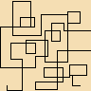
Maze.png
ME All over.png
Meander Breast Cancer.png
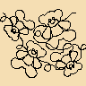
Meander Bears.png
Meander Flower Puffs.png
Meander Flowers & Flutterbys.png
Meander Hearts & Flutterbys.png
Meandering Hearts.png
Meandering Stars.png
Meandering Water.png
Modern Bud.png
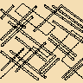
Pick up Sticks.png
Music Meander.png
Pebbles.png
Puzzle.png
Rectangles.png
Rose Garden.png
Simply Elephants.png
Simply Stars.png
Spine 2.png
Spine 1.png
Spiral.png
Square 4.png
Squiggle.png
Square Spiral.png
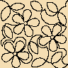
SS DBD Daisies.png
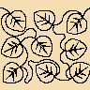
SS DBD Aspen Leaf.png
Squirts Light.png
SS DBD Flower Swirls.png
Stars Twice.png
Stipple Fractial.png
Star Edge To Edge.png
Stipple Classic.png
The Garden.png
Stipple Tight.png
Straight Line Stipple.png
Three Loop Border.png
Tree.png
Three Petal Triangle.png
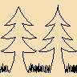
Tree Line.png
Tri Leaf Continuous.png
Triangle Loops.png
Triangle Curls.png
Tulips Triangle.png
Triangle Spikes.png
WF Autumn Orchard.png
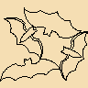
WF Bats.png
Wavy Hair.png
WF Beaded.png
WF Celebrate.png
WF Chevron.png
WF Buzzy Bee.png
WF Calico Flowers.png
WF Cowboy Boots.png
WF Crazy Lines.png
WF Chickadees.png
WF Creeping Vines.png
WF Critters.png
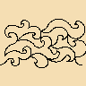
WF Curling Waves.png
WF Dog Pawprints.png
WF Eclipse.png
WF Flower Twine.png
WF Greek Maze.png
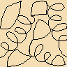
WF Kite Tales.png
WF Maple.png
WF Party Balloons.png
WF Paws and Bones.png
WF scratch Modern.png
WF Simply swirly.png
WF Wallpaper.png
WF Whirly.png
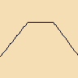
Zig Zag.png
Wind.png
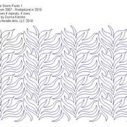
0895-FireStorm-PNT-1-jpg.JPG
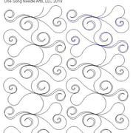
3221-Sweetheart-PNT2A-jpg.JPG
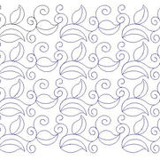
3796-Green-Tea-Lvs-PNT-1.JPG
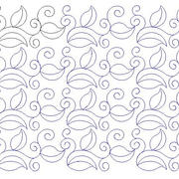
3796-Green-Tea-Lvs-PNT-1.JPG
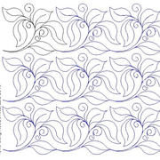
3797-Chocolate-Lvs-PNT-1.JPG
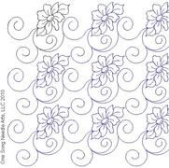
3799-Home-Tweet-Home-PNT-2.JPG
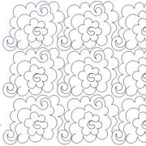
3801-DreamyClouds-PNT1A-jpg.JPG
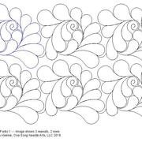
3803-Brandywine-PNT1-jpg.JPG
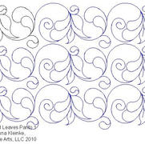
3806-Fth-Leaves-PNT-1.JPG
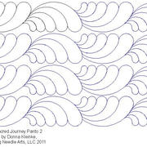
4008-Sacred-Jr-PNT-2.JPG
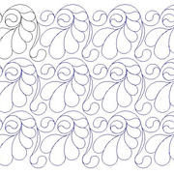
4000-Fth-Bless-PNT-1.JPG
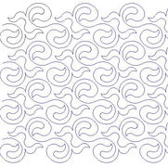
6000-Ariana-PNT1.JPG
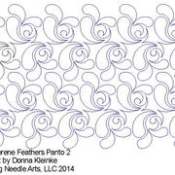
6004-Serene-Fth-PNT2.JPG
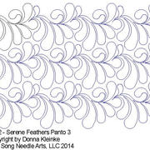
6012-Serene-Fth-PNT3.JPG
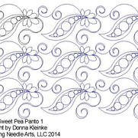
6008-Sweet-Pea-PNT1.JPG
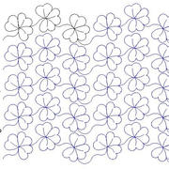
6005-Clover-PNT1.JPG
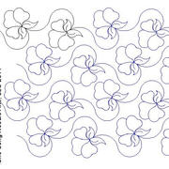
6006-Violet-Buds-PNT1.JPG
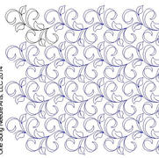
6009-Leaves-Ribbons-PNT1.JPG
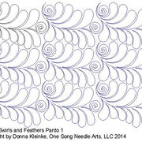
6016-Swirls-Fth-PNT1.JPG
6015-Btfly-Eleg-PNT1.JPG
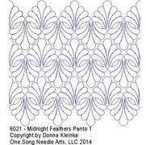
6021-MidnightFth-PNT1.JPG
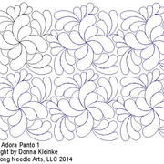
6022-Adora-PNT1.JPG
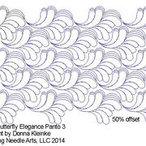
6023-Btfly-Eleg-PNT3.JPG
6024-Adora-PNT3.JPG
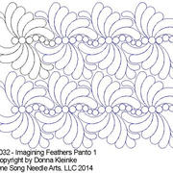
6032-ImaginingFth-PNT1.JPG
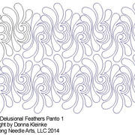
6030-Delusional-Fth-PNT1.JPG
6034-Adora-PNT4.JPG
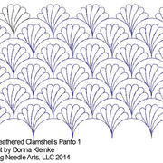
6035-Fth-Clamsh-PNT1.JPG
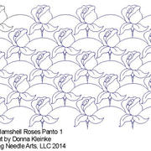
6036-Clamsh-Rose-PNT1.JPG
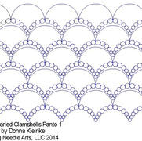
6038-Prl-Clamsh-PNT1.JPG
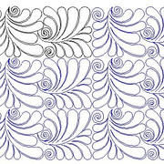
6213-SwirlsFth-PntBd1.JPG
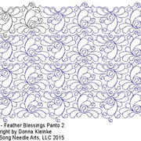
6224-FthBless-PNT2.JPG
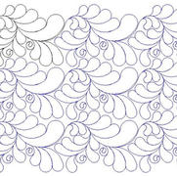
6225-FthBless-PNT3.JPG
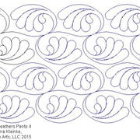
6227-MidnightFth-PNT4.JPG
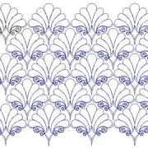
6228-RibbonRhap-PNT1.JPG
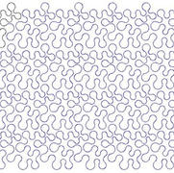
6319-Meandering-PNT1.JPG
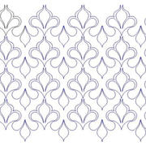
6320-Joyful-Teardrops-PNT1.JPG
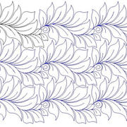
6323-Lavish-Lvs-PNT1.JPG
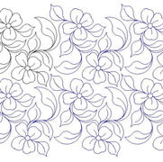
6324-Blossoms-PNT1.JPG
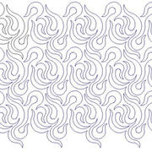
6322-Candlelight-PNT1.JPG
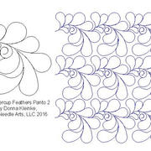
7016-ButtercupFth-PNT-2.JPG
7022-Kokoro-PNT1.JPG
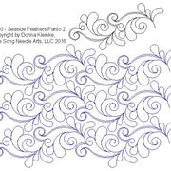
7020-SeasideFth-PNT2.JPG
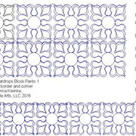
7265-BPNT-JoyflTrdp1.JPG
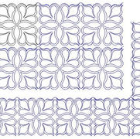
7268-BPNT-JoyflTrdp2.JPG
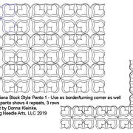
8007-Ariana-BPNT1-jpg.JPG
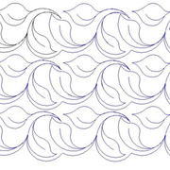
7698-Leaves-PNT1.JPG
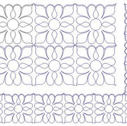
7275-BPNT-JoyflTrdp3.JPG
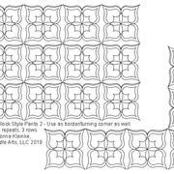
8008-Ariana-BPNT2-jpg.JPG
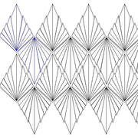
8022-Maya-PNT1-jpg.JPG
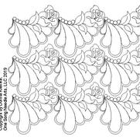
8023-DreamRose-PNT1-jpg.JPG
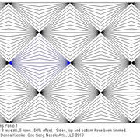
8025-Illusions-PNT1-jpg.JPG
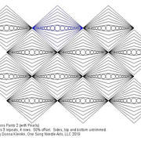
8026-Illusions-PNT2-jpg.JPG
8149-Bailey-PNT-1-jpg.JPG
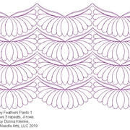
8154-RubyFth-PNT1-jpg.JPG
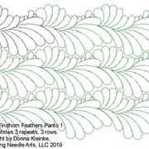
8156-FindhornFth-PNT-1-jpg.JPG
8160-Feather-Pinwheel-PNT1-jpg.JPG
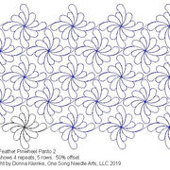
8161-Feather-Pinwheel-PNT2-jpg.JPG
8162-Feather-PNT1-jpg.JPG
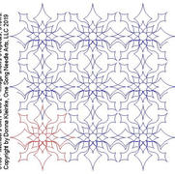
8163-MichaelsGift-PNT2-jpg.JPG
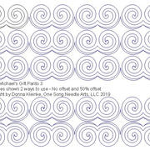
8164-MichaelsGift-PNT3-jpg.JPG
8165-SierraPeaks-PNT1-jpg.JPG
8166-SierraPeaks-PNT2-jpg.JPG
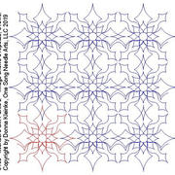
8163-MichaelsGift-PNT2-jpg.JPG
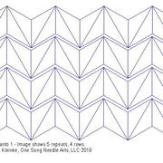
8168-Geometric-PNT1-jpg.JPG
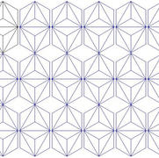
8169-Geometric-PNT2-jpg.JPG
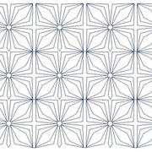
8170-Geometric-PNT3-jpg.JPG
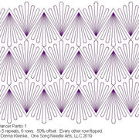
8171-StarDancer-PNT1-jpg.JPG
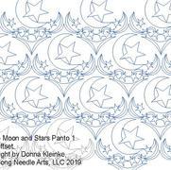
8177-MoonStars-PNT1-jpg.JPG
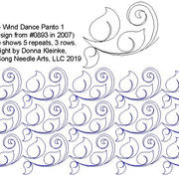
8185-Wind-Dance-PNT1-jpg.JPG
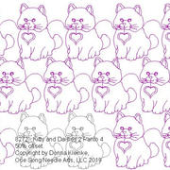
8272-KittyDaisies2-PNT4-jpg.JPG
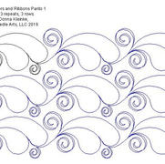
8217-FeathersRibb-PNT1-jpg.JPG
8288-ArtDeco-PNT1-jpg.JPG
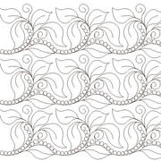
8291-ChocolateLeaves-PNT2-jpg.JPG
8301-FortunaFth-PNT1-jpg.JPG
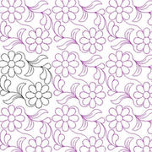
8302-Daisies-PNT4-jpg.JPG
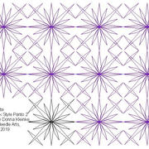
8306-Juliette-PNT2-jpg.JPG
8354-Spirit-Hawaii-PNT2-jpg.JPG
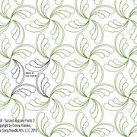
8364-Sacred-Jour-PNT3-jpg.JPG
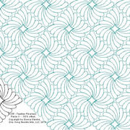
8355-Feather-Pinwheel-PNT3-jpg.JPG
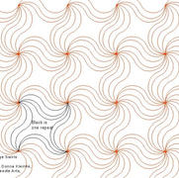
8365-OrangeSwirls-PNT1-jpg.JPG
8388-SedonaFth-PNT2-jpg.JPG
8372-SwirlsFth-PNT2-jpg.JPG
8389-SedonaFth-PNT3-jpg.JPG
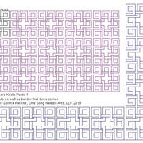
8410-SquareKnots-PNT1-jpg.JPG
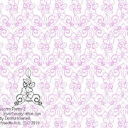
8466-Blossoms-PNT2-jpg.JPG
8703-French-Lily-PNT-1-jpg.JPG
8701-AngelWings-PNT-1-jpg.JPG
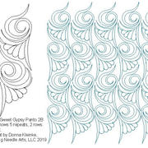
8592B-SweetGypsy-PNT2B-jpg.JPG
8704-French-Lily-PNT-3-jpg.JPG
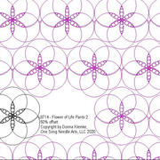
8714-Flower-of-Life-PNT-2-jpg.JPG
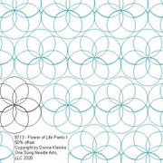
8713-Flower-of-Life-PNT-1-jpg.JPG
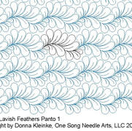
8705-LavishFth-PNT-1-jpg.JPG
8717-AdoraPinwheel-PNT-2-jpg.JPG
8725-Maureen-PNT-2-jpg.JPG
8719-Adora-PNT-6-jpg.JPG
8726-Wispy-Fth-PNT-3-jpg.JPG
8727-Seaside-Fth-PNT-3-jpg.JPG
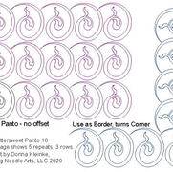
8732-Bittersweet-PNT-10-jpg.JPG
8733-Bittersweet-PNT-11-jpg.JPG
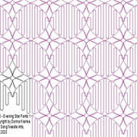
8748-EveningStar-PNT-1-jpg.JPG
8749-Adora-Pinwheel-PNT-3-jpg.JPG
8760-Camilla-PNT-4-jpg.JPG
8761-Clarisse-PNT-1-jpg.JPG
8763-Clarisse-PNT-3-jpg.JPG
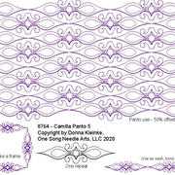
8764-Camilla-PNT-5-jpg.JPG
8766-Cassidy-PNT-4-jpg.JPG
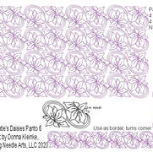
8770-Katies-Daisies-PNT-6-jpg.JPG
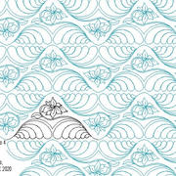
8768-Katies-Daisies-PNT-4-jpg.JPG
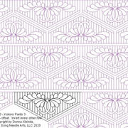
8773-Kokoro-PNT-3-jpg.JPG
8776-Buttercream-Fth-PNT-1-jpg.JPG
8778-Simone-PNT-1-jpg.JPG
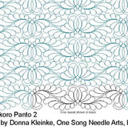
8772-Kokoro-PNT-2-jpg.JPG
8795-Jewel-PNT-1-jpg.JPG
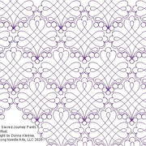
8787-Sacred-Jour-PNT-5-jpg.JPG
8786-Sacred-Jour-PNT-4-jpg.JPG
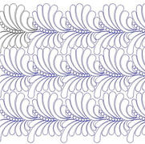
A7877-Zuri-PNT1.JPG
Out of gallery
2016 Stitches by the Sea

